**Supplemental Figures:**

**S1.** Root biomass for *L. vulgaris* and native plants grown in soil from IL (n = 25). Missing data in *Linaria vulgaris* pots is the result of few plants growing in IL soil. Error bars represent mean plus standard error.

**S2.** Shoot biomass for *L. vulgaris* and native plants grown in soil from IL (n = 25). Error bars represent mean plus standard error.

**S3.** N uptake rates (NUR) in plants grown in CO soil (n = 23). Error bars represent mean plus one standard error.

**S4.** N uptake rates (NUR) in plants grown in IL soil (n = 13). Missing data in *Linaria vulgaris* pots is the result of few plants growing in IL soil. Error bars represent mean plus one standard error.

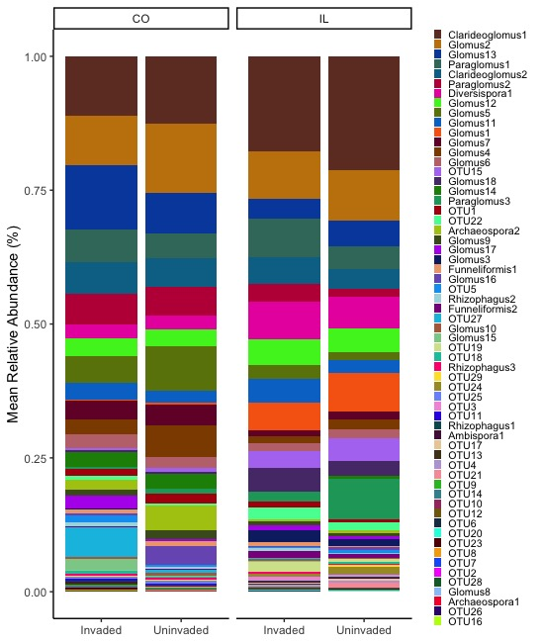

**S5.** Taxa plot of mean OTU relative abundances (%) by state and invasion history. Bars are organized from most to least abundant in all treatments (top to bottom).

**Appendix 1.** Model summaries for plant presence, root biomass, and soil nutrient datasets. N/A in the ΔAICc column is the result of using quasipoisson distributions that lack AIC values. N/A in the Model column means that the best-fit model has only one predictor. The model listed for each dataset is the best-fit model.

|  |  |  |  |  |  |  |  |
| --- | --- | --- | --- | --- | --- | --- | --- |
| Dataset | State | Predictors | Model | ΔAICc | X2 | df | P |
| Presence | CO | Invasion  Species | Interactive | 2.8 | 9.09  5.81 | 1  1 | 0.002  0.01 |
| Presence | IL | Invasion  Species | Interactive | 2.3 | 2.87  33.8 | 1  1 | 0.089  <0.001 |
| *L. vulgaris* Root Biomass | CO | Invasion  Fertilizer | Interactive | 1.3 | 20.6  23.0 | 21  21 | 0.005  0.075 |
| Native Species Root Biomass | CO | Invasion  Fertilizer | Additive | 3.0 | 21.5  22.0 | 22  22 | 0.046  0.304 |
| Native Species Root Biomass | IL | Invasion  Fertilizer | Interactive | 2.5 | 23.0  23.0 | 22  22 | 0.149  0.024 |
| *L. vulgaris* NUR | CO | Invasion  Fertilizer | Interactive | N/A | 12.0  12.0 | 11  11 | 0.377  0.986 |
| Native Species NUR | CO | Invasion  Fertilizer | Interactive | N/A | 12.0  12.0 | 11  11 | 0.185  0.926 |
| Native Species NUR | IL | Invasion  Fertilizer | Interactive | N/A | 11.0  8.98 | 9  9 | 0.179  0.106 |
| pH | Both | State  Invasion | Additive | 2.0 | 78.0  71.3 | 68  68 | <0.001  0.233 |
| NO3 | Both | State  Invasion | Interactive | N/A | 77.3  72.6 | 73  73 | 0.105  0.577 |
| NH4 | Both | State  Invasion | Additive | 2.1 | 72.0  70.0 | 69  69 | <0.001  0.295 |
| PO4 | Both | State  Invasion | Interactive | 2.1 | 76.0  78.0 | 75  75 | 0.072  0.592 |

**Appendix 2.** Indicator OTUs with mean relative abundances (%) ± standard error in CO and IL and p-values of OTUs that differ significantly by state.

|  |  |  |  |  |  |
| --- | --- | --- | --- | --- | --- |
| CO | | | IL | | |
| OTU | Mean Relative Abundance (%) | P-Value | OTU | Mean Relative Abundance (%) | P-value |
| Glomus7 | 3.6±0.3 | 0.001 | Diversispora1 | 6.4±0.4 | 0.001 |
| Paraglomus2 | 5.5±0.7 | 0.001 | Glomus3 | 1.7±0.2 | 0.001 |
| OTU11 | 0.3±0.07 | 0.001 | Glomus1 | 6.3±1.1 | 0.001 |
| OTU13 | 0.3±0.08 | 0.002 | OTU15 | 3.8±0.7 | 0.001 |
| OTU8 | 0.1±0.03 | 0.001 | Funneliformis2 | 1.1±0.2 | 0.001 |
| Glomus13 | 9.7±1.5 | 0.002 | OTU12 | 0.2±0.06 | 0.002 |
| Glomus5 | 6.7±1.5 | 0.001 | Glomus18 | 3.7±1.3 | 0.001 |
| Glomus9 | 1.4±0.2 | 0.001 | OTU22 | 1.8±0.3 | 0.002 |
| OTU9 | 2.2±0.07 | 0.002 | OTU4 | 0.3±0.09 | 0.002 |
| OTU25 | 0.3±0.1 | 0.001 | Clarideoglomus1 | 18.8±1.8 | 0.002 |
| OTU14 | 0.1±0.04 | 0.005 | Glomus8 | 0.05±0.02 | 0.006 |
| Archaeospora2 | 3.1±1.0 | 0.001 | OTU3 | 0.5±0.2 | 0.001 |
| Clarideoglomus2 | 5.6±0.5 | 0.008 | OTU6 | 0.1±0.05 | 0.010 |
| Glomus10 | 0.4±0.07 | 0.017 | Paraglomus3 | 4.9±2.3 | 0.001 |
| OTU28 | 0.06±0.02 | 0.029 | OTU20 | 0.1±0.09 | 0.028 |
| Glomus14 | 2.7±1.3 | 0.001 | OTU19 | 1.1±0.6 | 0.004 |
| Glomus4 | 4.2±1.0 | 0.002 | OTU17 | 0.3±0.1 | 0.037 |
| OTU26 | 0.03±0.01 | 0.030 | OTU24 | 1.0±0.6 | 0.005 |
| OTU2 | 0.1±0.05 | 0.009 | OTU21 | 0.6±0.4 | 0.012 |
| OTU27 | 3.0±2.1 | 0.012 |  |  |  |

**Appendix 3.** Indicator OTUs for invaded and uninvaded soil in CO and IL of OTUs with mean relative abundances (%) ± standard error and p-values of OTUs that differ significantly by invasion.

|  |  |  |  |  |
| --- | --- | --- | --- | --- |
| OTU | State | Invasion | Mean | P-Value |
| Glomus3 | CO | Invaded | 0.2±0.06 | 0.003 |
| Glomus16 | CO | Uninvaded | 3.4±2.0 | 0.038 |
| Paraglomus2 | IL | Invaded | 3.1±0.3 | 0.001 |
| OTU1 | IL | Invaded | 1.3±0.1 | 0.002 |
| Paraglomus1 | IL | Invaded | 7.3±0.9 | 0.001 |
| OTU27 | IL | Invaded | 0.2±0.08 | 0.002 |
| Glomus15 | IL | Invaded | 0.3±0.1 | 0.001 |
| Rhizophagus2 | IL | Invaded | 0.4±0.1 | 0.001 |
| OTU11 | IL | Invaded | 0.1±0.05 | 0.002 |
| Glomus16 | IL | Uninvaded | 0.7±0.2 | 0.035 |
| Glomus14 | IL | Uninvaded | 0.5±0.2 | 0.046 |
| OTU29 | IL | Uninvaded | 0.2±0.1 | 0.046 |
| OTU10 | IL | Uninvaded | 0.08±0.02 | 0.046 |